**Practical session 2**

*For the practical part of this lab please save the Python programs that you create and take screenshots of the execution (evaluation) of your programs.*

**Tasks:**

1) Write an algorithm that describes how to make scrambled eggs, try to use control words, like IF, WHEN, UNTIL, WHILE, WAIT, AND, OR.

Get a frying pan over low heat

Put some butter until it melt

And crack 3 large eggs into a bowl

When the butter is melt

Then pour the beaten eggs into the pan

While the eggs cooking add some salt and pepper

And you will have a delicious scrambled eggs

2) Is Idle (the Python language shell) an Interpreter or an Compiler or both? Explain your answer.

I know is both because when I run a python code in a computer I will need to use an interpreter and If I need

3) Write a command in the Idle shell that says “Hello world”

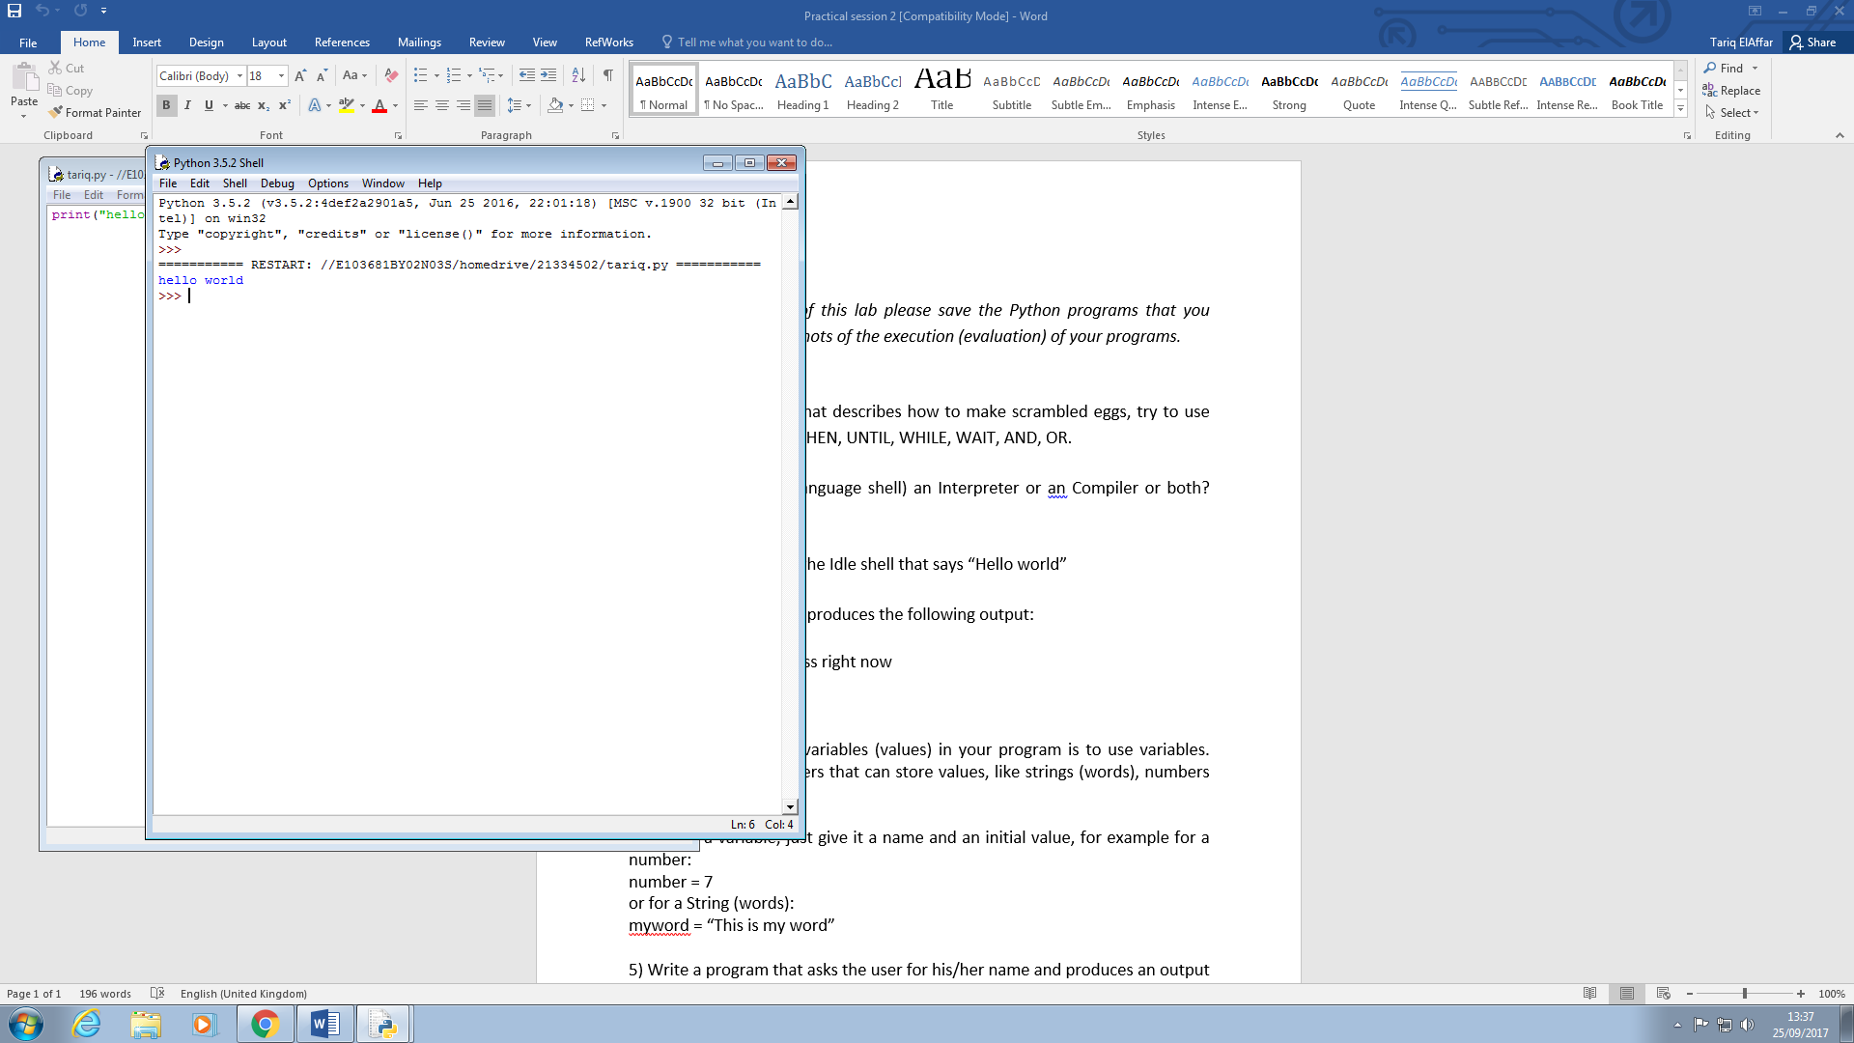

4) Write a program that produces the following output:

Hello World

I am in my ISD class right now

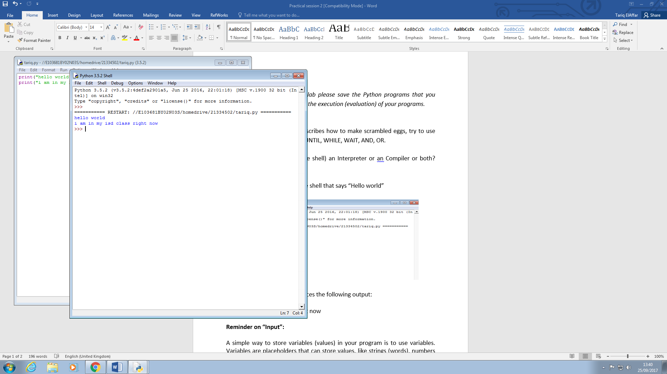

**Reminder on “Input”:**

A simple way to store variables (values) in your program is to use variables. Variables are placeholders that can store values, like strings (words), numbers (int) etc.

To create a variable, just give it a name and an initial value, for example for a number:

number = 7

or for a String (words):

myword = “This is my word”

5) Write a program that asks the user for his/her name and produces an output like:

Hi there, what is your name? >User input to be read<

Hello

“User name”

How are you?

